FSM for Gameplay mechanics and Settings

FSM for gameplay mechanics:

F = 1 if Game is currently in progress, 0 if it enters game over” stage

If control output is up, U = 1, if control output is left, L =1, if control out put is Right, R =1, if control output is down, D=1. It would be zero if snake is not moving in that direction.

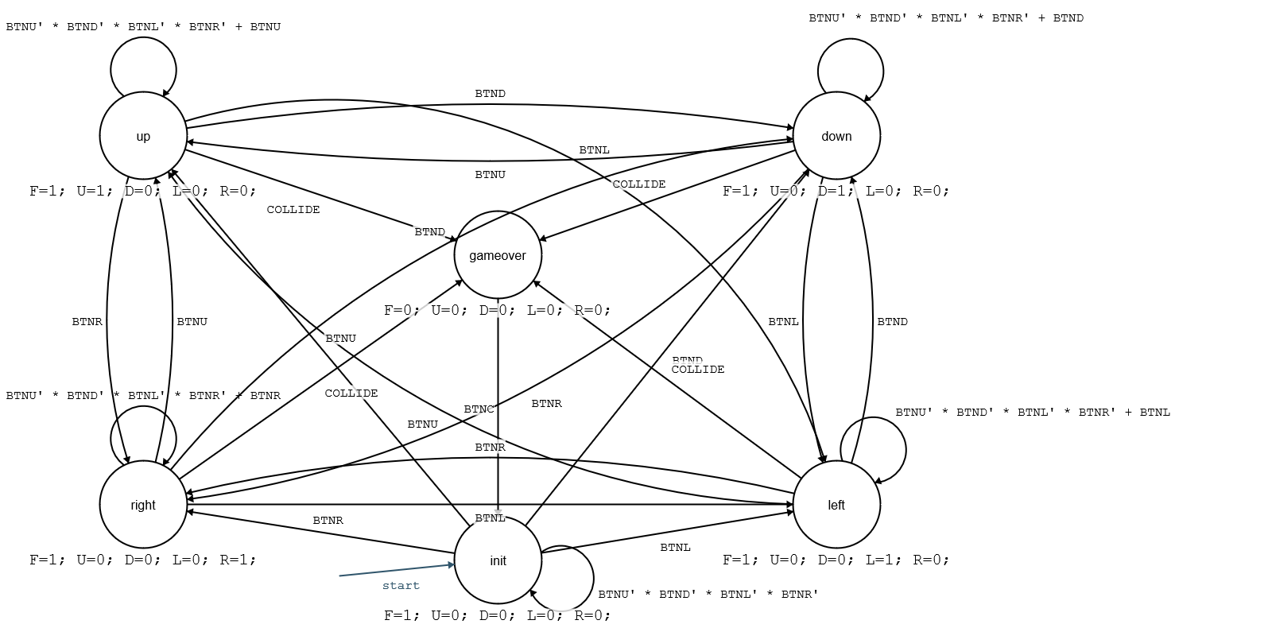

Game Play Settings FSM:

Buttons up and down scrolls for difficulty, while buttons right and center scrolls for the solid wall or wrapping wall setting. Difficulty outputs are set so if Easy is selected, E=1, Hard is selected, H=1, Medium is selected M =1.

